Department of Software Engineering
Demonstration of the Rent-a-Car Management System
Submitted by:
Muhammad Aliyan
25021598-245
Ghulam Meeran
25021598-191
Abdul Mateen
25021598-259
Jahanzaib Khalid
25021598-180
Section:
AB
Submitted to:
Sir Muhammad Ejaz

Fleet 3
Vehicle.java 3
VehicleDAO.java 4
Customers 6
Customers.java 6
CustomerDAO.java 7
Drivers 9
Driver.java 9
DriverDAO.java 10
Sales 12
Sale.java 12
SaleDAO.java 14
Payments 18
Payment.java 18
PaymentDAO.java 19
Expenses 21
Expense.java 21
ExpenseDAO.java 22

Fleet

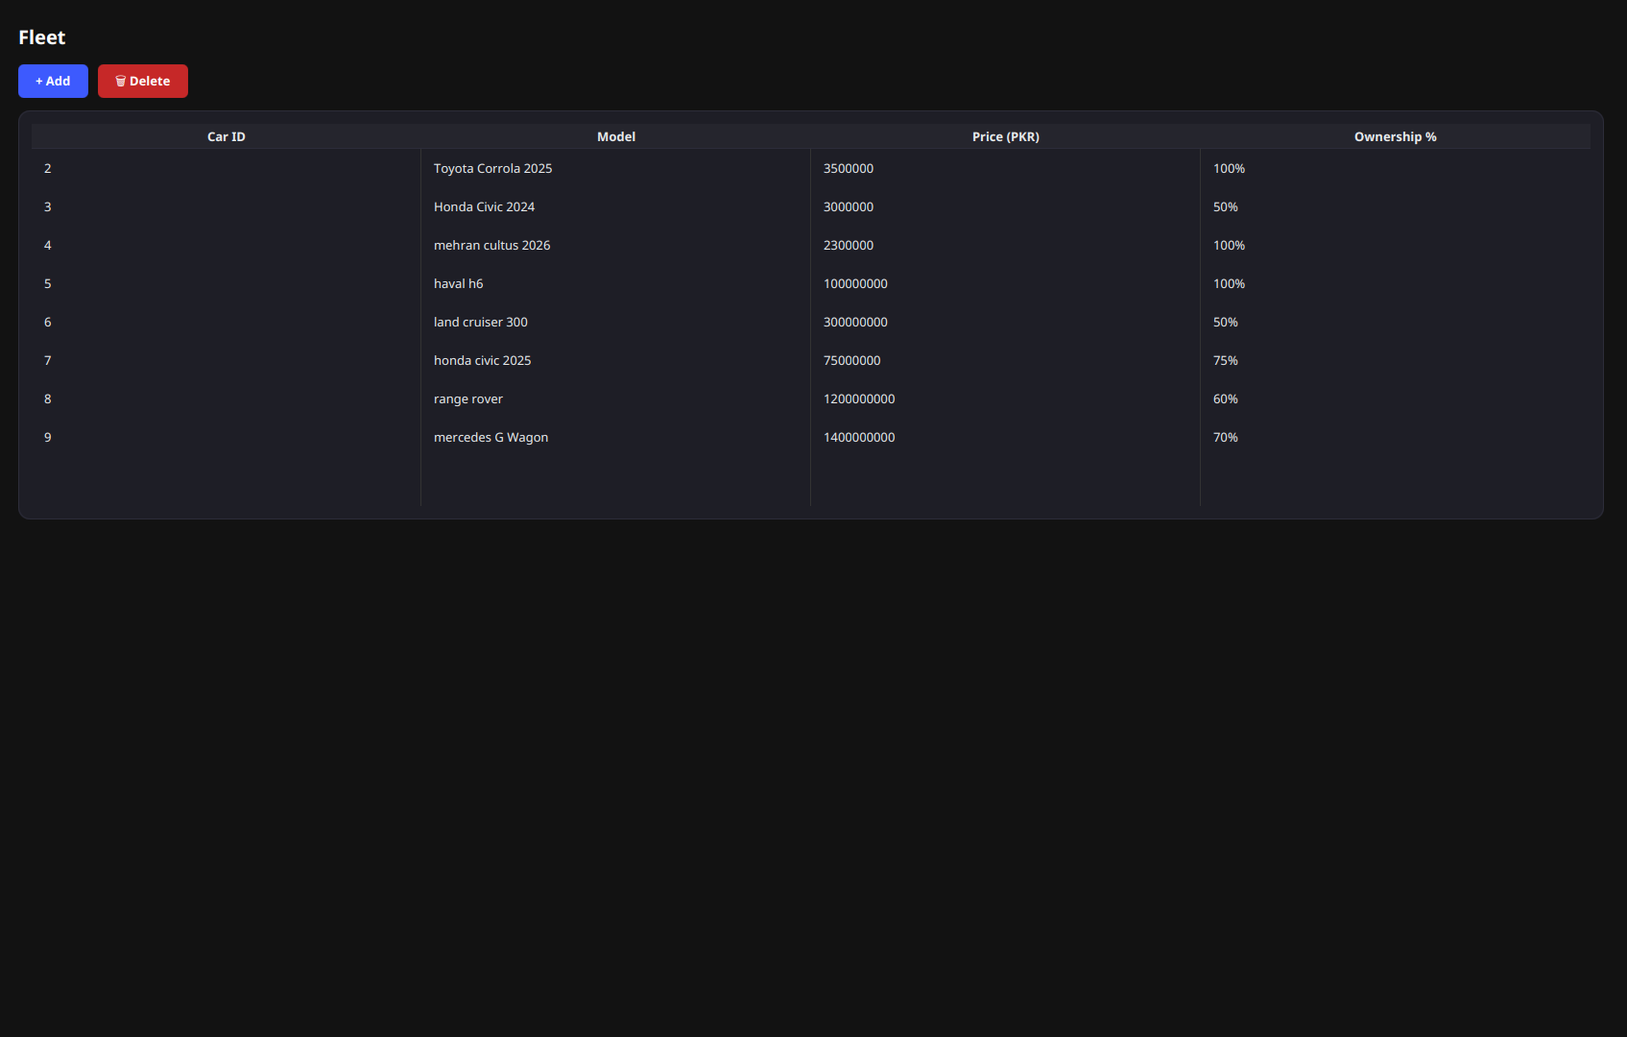

Vehicle.java
package models;

public class Vehicle {
private int carId;
private String model;
private String purchasePrice;
private double ownershipPercentage;

public Vehicle(int carId, String model, String purchasePrice, double ownershipPercentage) {
this.carId = carId;
this.model = model;
this.purchasePrice = purchasePrice;
this.ownershipPercentage = ownershipPercentage;
}

public int getCarId() {
return carId;
}

public String getModel() {
return model;
}

public String getPurchasePrice() {
return purchasePrice;
}

public double getOwnershipPercentage() {
return ownershipPercentage;
}
}

VehicleDAO.java
package database;

import models.Vehicle;
import java.sql.Connection;
import java.sql.PreparedStatement;
import java.sql.ResultSet;
import java.sql.SQLException;
import java.util.ArrayList;
import java.util.List;

public class VehicleDAO {

public List<Vehicle> listVehicles() throws SQLException {
String sql = "SELECT car_ID, model, purchase_Price, ownership_Percentage FROM Vehicles";

try (
Connection conn = DBConfig.getConnection();
PreparedStatement ps = conn.prepareStatement(sql);
ResultSet rs = ps.executeQuery()) {
List<Vehicle> vehicles = new ArrayList<>();

while (rs.next()) {
vehicles.add(new Vehicle(
rs.getInt("car_ID"),
rs.getString("model"),
rs.getString("purchase_Price"),
rs.getDouble("ownership_Percentage")));
}

return vehicles;
}
}

public void insert(String model, String purchasePrice, double ownershipPercentage) throws SQLException {
String sql = "INSERT INTO Vehicles (model, purchase_Price, ownership_Percentage) VALUES (?, ?, ?)";
try (Connection conn = DBConfig.getConnection();
PreparedStatement ps = conn.prepareStatement(sql)) {
ps.setString(1, model);
ps.setString(2, purchasePrice);
ps.setDouble(3, ownershipPercentage);
ps.executeUpdate();
}
}

public void delete(int carId) throws SQLException {
try (Connection conn = DBConfig.getConnection()) {
conn.setAutoCommit(false);

try (PreparedStatement psCheck = conn.prepareStatement(
"SELECT COUNT(*) FROM Sales WHERE car_id = ?")) {
psCheck.setInt(1, carId);
try (ResultSet rs = psCheck.executeQuery()) {
if (rs.next() && rs.getInt(1) > 0) {
conn.rollback();
throw new SQLException("Cannot delete vehicle: there are sales referencing this vehicle. Remove or reassign those sales first.");
}
}
}

try (PreparedStatement psClear = conn.prepareStatement(
"UPDATE Expenses SET vehicle_id = NULL WHERE vehicle_id = ?")) {
psClear.setInt(1, carId);
psClear.executeUpdate();
}

try (PreparedStatement ps = conn.prepareStatement(
"DELETE FROM Vehicles WHERE car_ID = ?")) {
ps.setInt(1, carId);
ps.executeUpdate();
}
conn.commit();
}
}
}

Customers

Customers
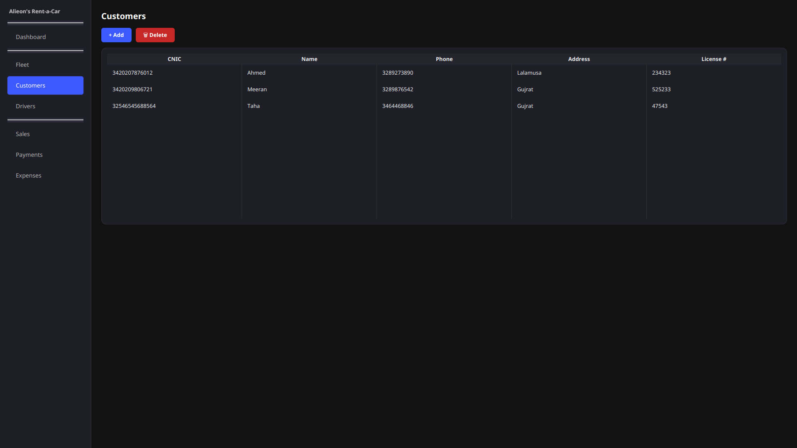

Customers.java
package models;

public class Customer {
private long cnic;
private String name;
private String address;
private long phone;
private String license;

public Customer(long cnic, String name, String address, long phone, String license) {
this.cnic = cnic;
this.name = name;
this.address = address;
this.phone = phone;
this.license = license;
}

public long getCnic() {
return cnic;
}

public String getName() {
return name;
}

public long getPhone() {
return phone;
}

public String getAddress() {
return address;
}

public String getLicense() {
return license;
}
}

CustomerDAO.java

package database;

import models.Customer;

import java.sql.Connection;
import java.sql.PreparedStatement;
import java.sql.ResultSet;
import java.sql.SQLException;
import java.util.ArrayList;
import java.util.List;

public class CustomerDAO {

public List<Customer> listCustomers() throws SQLException {
String sql = "SELECT customer_cnic, custome_name, address, phone_number, license_number FROM Customers";

try (
Connection conn = DBConfig.getConnection();
PreparedStatement ps = conn.prepareStatement(sql);
ResultSet rs = ps.executeQuery()) {
List<Customer> customers = new ArrayList<>();
while (rs.next()) {
customers.add(new Customer(
rs.getLong("customer_cnic"),
rs.getString("custome_name"),
rs.getString("address"),
rs.getLong("phone_number"),
rs.getString("license_number")));
}
return customers;
}
}

public void insert(long cnic, String name, String address, long phone, String license) throws SQLException {
String sql = "INSERT INTO Customers (customer_cnic, custome_name, address, phone_number, license_number) VALUES (?, ?, ?, ?, ?)";
try (Connection conn = DBConfig.getConnection();
PreparedStatement ps = conn.prepareStatement(sql)) {
ps.setLong(1, cnic);
ps.setString(2, name);
ps.setString(3, address);
ps.setLong(4, phone);
ps.setString(5, license);
ps.executeUpdate();
}
}

public void delete(long cnic) throws SQLException {
String sql = "DELETE FROM Customers WHERE customer_cnic = ?";
try (Connection conn = DBConfig.getConnection();
PreparedStatement ps = conn.prepareStatement(sql)) {
ps.setLong(1, cnic);
ps.executeUpdate();
}
}
}

Drivers
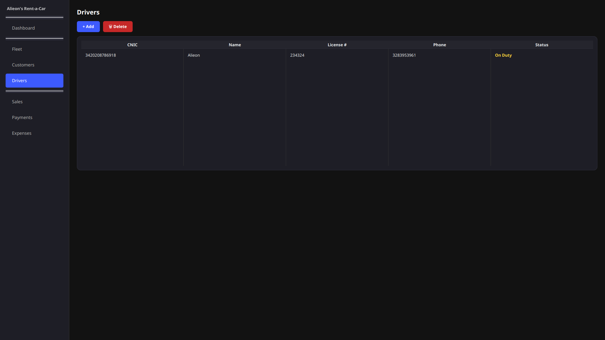

Driver.java

package models;

public class Driver {
private long cnic;
private String name;
private long license;
private long phone;
private String status;

public Driver(long cnic, String name, long license, long phone, String status) {
this.cnic = cnic;
this.name = name;
this.license = license;
this.phone = phone;
this.status = status;
}

public long getCnic() {
return cnic;
}

public String getName() {
return name;
}

public long getLicense() {
return license;
}

public long getPhone() {
return phone;
}

public String getStatus() {
return status;
}
}

DriverDAO.java

package database;

import models.Driver;

import java.sql.Connection;
import java.sql.PreparedStatement;
import java.sql.ResultSet;
import java.sql.SQLException;
import java.util.ArrayList;
import java.util.List;

public class DriverDAO {

public List<Driver> listDrivers() throws SQLException {
String sql = "SELECT d.driver_cnic, d.driver_name, d.license_number, d.phone_number, " +
" CASE WHEN active.driver_cnic IS NOT NULL THEN 'On Duty' " +
" ELSE d.status END AS eff_status " +
"FROM Drivers d " +
"LEFT JOIN ( " + " SELECT DISTINCT driver_cnic FROM Sales " +
" WHERE end_date >= CURDATE() AND driver_cnic > 0 " +
") active ON active.driver_cnic = d.driver_cnic";

try (
Connection conn = DBConfig.getConnection();
PreparedStatement ps = conn.prepareStatement(sql);
ResultSet rs = ps.executeQuery()) {
List<Driver> drivers = new ArrayList<>();
while (rs.next()) {
drivers.add(new Driver(
rs.getLong("driver_cnic"),
rs.getString("driver_name"),
rs.getLong("license_number"),
rs.getLong("phone_number"),
rs.getString("eff_status")));
}
return drivers;
}
}

public void insert(long cnic, String name, long license, long phone, String status) throws SQLException {
String sql = "INSERT INTO Drivers (driver_cnic, driver_name, license_number, phone_number, status) VALUES (?, ?, ?, ?, ?)";
try (Connection conn = DBConfig.getConnection();
PreparedStatement ps = conn.prepareStatement(sql)) {
ps.setLong(1, cnic);
ps.setString(2, name);
ps.setLong(3, license);
ps.setLong(4, phone);
ps.setString(5, status);
ps.executeUpdate();
}
}

public void delete(long cnic) throws SQLException {
String sql = "DELETE FROM Drivers WHERE driver_cnic = ?";
try (Connection conn = DBConfig.getConnection();
PreparedStatement ps = conn.prepareStatement(sql)) {
ps.setLong(1, cnic);
ps.executeUpdate();
}
}
}

Sales
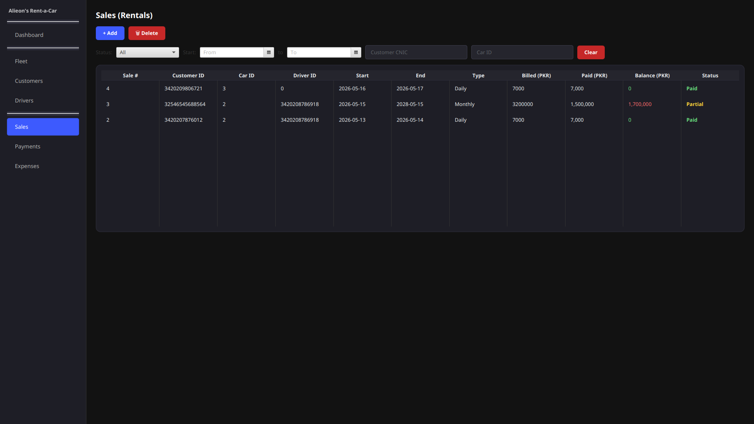

Sale.java

package models;

import java.time.LocalDate;

public class Sale {
private int saleId;
private long customerCnic;
private int carId;
private long driverCnic;
private LocalDate startDate;
private LocalDate endDate;
private String rentalType;
private int totalAmount;

public Sale(long customerCnic, int carId, long driverCnic,
LocalDate start, LocalDate end, String type, int total) {
this.customerCnic = customerCnic;
this.carId = carId;
this.driverCnic = driverCnic;
this.startDate = start;
this.endDate = end;
this.rentalType = type;
this.totalAmount = total;
}

public Sale(int saleId, long customerCnic, int carId, long driverCnic,
LocalDate start, LocalDate end, String type, int total) {
this(customerCnic, carId, driverCnic, start, end, type, total);
this.saleId = saleId;
}

private double amountPaid = -1;
private double balance = -1;
private String paymentStatus = "";

public void setAmountPaid(double v) {
this.amountPaid = v;
}

public void setBalance(double v) {
this.balance = v;
}

public void setPaymentStatus(String v) {
this.paymentStatus = v;
}

public int getSaleId() {
return saleId;
}

public long getCustomerCnic() {
return customerCnic;
}

public int getCarId() {
return carId;
}

public long getDriverCnic() {
return driverCnic;
}

public LocalDate getStartDate() {
return startDate;
}

public LocalDate getEndDate() {
return endDate;
}

public String getRentalType() {
return rentalType;
}

public int getTotalAmount() {
return totalAmount;
}

public double getAmountPaid() {
return amountPaid;
}

public double getBalance() {
return balance;
}

public String getPaymentStatus() {
return paymentStatus;
}

public boolean isOverdue() {
return endDate != null && endDate.isBefore(LocalDate.now())
&& !"Paid".equals(paymentStatus);
}
}

SaleDAO.java

package database;

import models.Sale;

import java.sql.Connection;
import java.sql.Date;
import java.sql.PreparedStatement;
import java.sql.ResultSet;
import java.sql.SQLException;
import java.time.LocalDate;
import java.util.ArrayList;
import java.util.List;

public class SaleDAO {

public List<Sale> listSales() throws SQLException {
String sql = "SELECT sale_id, customer_cnic, car_id, driver_cnic, start_date, end_date, rental_type, Total FROM Sales";

try (
Connection conn = DBConfig.getConnection();
PreparedStatement ps = conn.prepareStatement(sql);
ResultSet rs = ps.executeQuery()) {
List<Sale> sales = new ArrayList<>();
while (rs.next()) {
Date start = rs.getDate("start_date");
Date end = rs.getDate("end_date");

sales.add(new Sale(
rs.getInt("sale_id"),
rs.getLong("customer_cnic"),
rs.getInt("car_id"),
rs.getLong("driver_cnic"),
start != null ? start.toLocalDate() : null,
end != null ? end.toLocalDate() : null,
rs.getString("rental_type"),
rs.getInt("Total")));
}
return sales;
}
}

public void insert(long customerCnic, int carId, long driverCnic,
LocalDate start, LocalDate end, String rentalType, int total) throws SQLException {
String sql = "INSERT INTO Sales (customer_cnic, car_id, driver_cnic, start_date, end_date, rental_type, Total) VALUES (?, ?, ?, ?, ?, ?, ?)";
try (Connection conn = DBConfig.getConnection();
PreparedStatement ps = conn.prepareStatement(sql)) {
ps.setLong(1, customerCnic);
ps.setInt(2, carId);
if (driverCnic > 0)
ps.setLong(3, driverCnic);
else
ps.setNull(3, java.sql.Types.BIGINT);
ps.setDate(4, start != null ? Date.valueOf(start) : null);
ps.setDate(5, end != null ? Date.valueOf(end) : null);
ps.setString(6, rentalType);
ps.setInt(7, total);
ps.executeUpdate();
}
}

public void delete(int saleId) throws SQLException {
String sql = "DELETE FROM Sales WHERE sale_id = ?";
try (Connection conn = DBConfig.getConnection();
PreparedStatement ps = conn.prepareStatement(sql)) {
ps.setInt(1, saleId);
ps.executeUpdate();
}
}

public List<Sale> listSalesWithBalance() throws SQLException {
String sql = "SELECT s.sale_id, s.customer_cnic, s.car_id, s.driver_cnic, " +
"s.start_date, s.end_date, s.rental_type, s.Total, " +
"COALESCE(SUM(p.money_paid), 0) AS amount_paid " +
"FROM Sales s " +
"LEFT JOIN Payment p ON p.sale_id = s.sale_id " +
"GROUP BY s.sale_id, s.customer_cnic, s.car_id, s.driver_cnic, " +
"s.start_date, s.end_date, s.rental_type, s.Total " +
"ORDER BY s.sale_id DESC";

try (Connection conn = DBConfig.getConnection();
PreparedStatement ps = conn.prepareStatement(sql);
ResultSet rs = ps.executeQuery()) {

List<Sale> list = new ArrayList<>();
while (rs.next()) {
Date start = rs.getDate("start_date");
Date end = rs.getDate("end_date");
int total = rs.getInt("Total");
double paid = rs.getDouble("amount_paid");

Sale sale = new Sale(
rs.getInt("sale_id"),
rs.getLong("customer_cnic"),
rs.getInt("car_id"),
rs.getLong("driver_cnic"),
start != null ? start.toLocalDate() : null,
end != null ? end.toLocalDate() : null,
rs.getString("rental_type"),
total);
sale.setAmountPaid(paid);
sale.setBalance(total - paid);
if (paid >= total)
sale.setPaymentStatus("Paid");
else if (paid > 0)
sale.setPaymentStatus("Partial");
else
sale.setPaymentStatus("Unpaid");
list.add(sale);
}
return list;
}
}
}

Payments
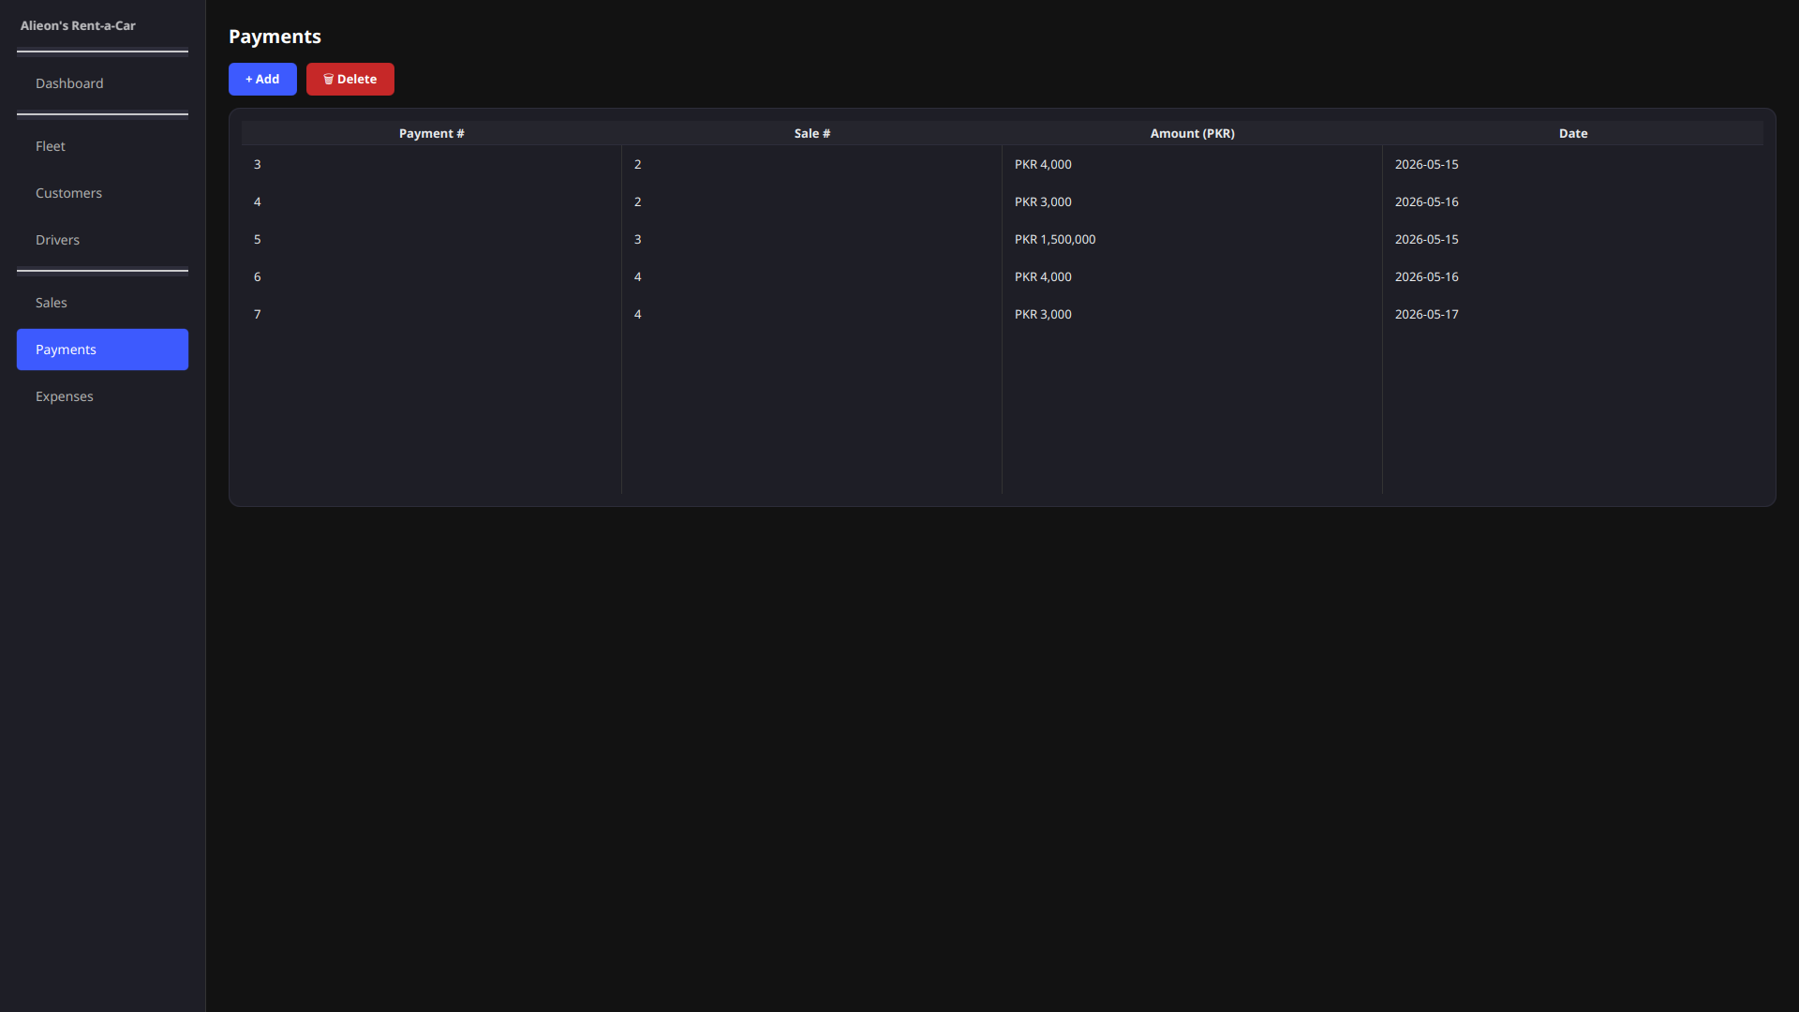

Payment.java

package models;

import java.time.LocalDate;

public class Payment {
private int paymentId;
private int saleId;
private double moneyPaid;
private LocalDate paymentDate;

public Payment(int paymentId, int saleId, double moneyPaid, LocalDate paymentDate) {
this.paymentId = paymentId;
this.saleId = saleId;
this.moneyPaid = moneyPaid;
this.paymentDate = paymentDate;
}

public int getPaymentId() {
return paymentId;
}

public int getSaleId() {
return saleId;
}

public double getMoneyPaid() {
return moneyPaid;
}

public LocalDate getPaymentDate() {
return paymentDate;
}
}

PaymentDAO.java

package database;

import models.Payment;

import java.sql.Connection;
import java.sql.Date;
import java.sql.PreparedStatement;
import java.sql.ResultSet;
import java.sql.SQLException;
import java.time.LocalDate;
import java.util.ArrayList;
import java.util.List;

public class PaymentDAO {
public List<Payment> listPayments() throws SQLException {
String sql = "SELECT payment_id, sale_id, money_paid, payment_date FROM Payment";

try (
Connection conn = DBConfig.getConnection();
PreparedStatement ps = conn.prepareStatement(sql);
ResultSet rs = ps.executeQuery()) {
List<Payment> payments = new ArrayList<>();
while (rs.next()) {
Date d = rs.getDate("payment_date");
payments.add(new Payment(
rs.getInt("payment_id"),
rs.getInt("sale_id"),
rs.getDouble("money_paid"),
d != null ? d.toLocalDate() : null));
}
return payments;
}
}

public void insert(int saleId, double moneyPaid, LocalDate date) throws SQLException {
String sql = "INSERT INTO Payment (sale_id, money_paid, payment_date) VALUES (?, ?, ?)";
try (Connection conn = DBConfig.getConnection();
PreparedStatement ps = conn.prepareStatement(sql)) {
ps.setInt(1, saleId);
ps.setDouble(2, moneyPaid);
ps.setDate(3, date != null ? Date.valueOf(date) : null);
ps.executeUpdate();
}
}

public void delete(int paymentId) throws SQLException {
String sql = "DELETE FROM Payment WHERE payment_id = ?";
try (Connection conn = DBConfig.getConnection();
PreparedStatement ps = conn.prepareStatement(sql)) {
ps.setInt(1, paymentId);
ps.executeUpdate();
}
}
}

Expenses
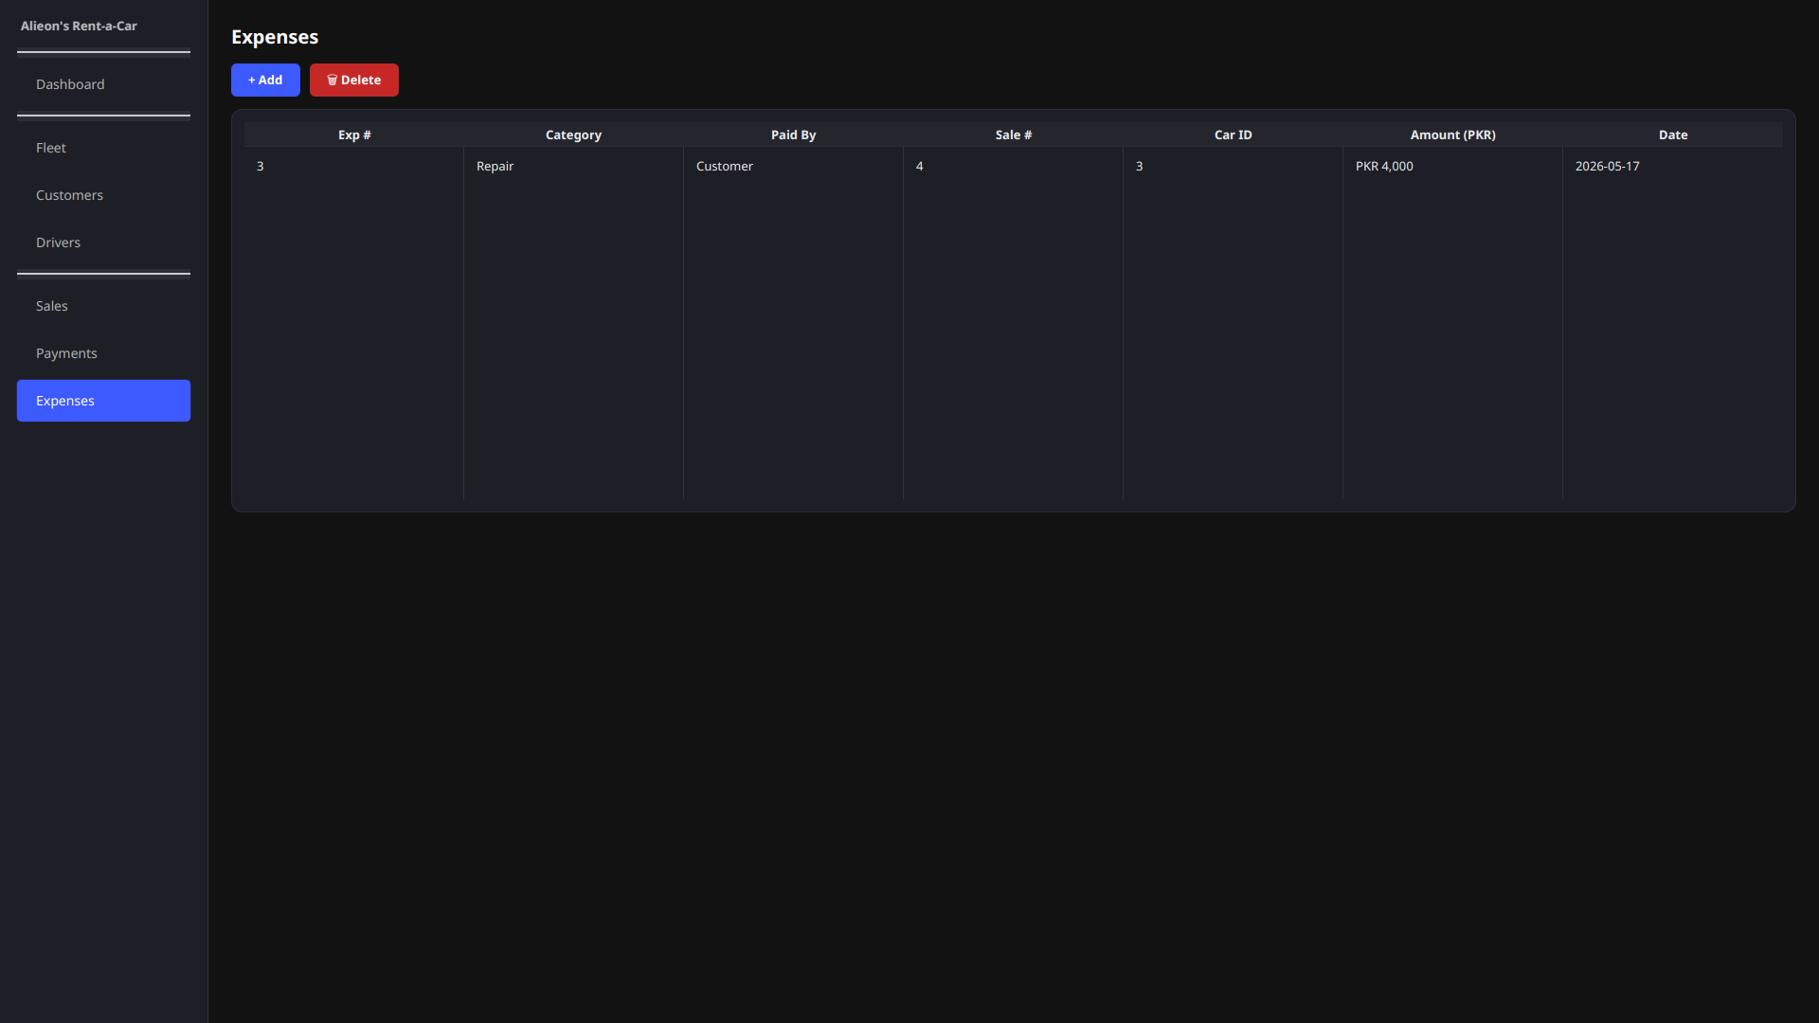

Expense.java
package models;

import java.time.LocalDate;

public class Expense {
private int expenseId;
private String type;
private String payer;
private int saleId;
private int vehicleId;
private double amount;
private LocalDate date;

public Expense(int expenseId, String type, String payer,
int saleId, int vehicleId, double amount, LocalDate date) {
this.expenseId = expenseId;
this.type = type;
this.payer = payer;
this.saleId = saleId;
this.vehicleId = vehicleId;
this.amount = amount;
this.date = date;
}

public int getExpenseId() {
return expenseId;
}

public String getType() {
return type;
}

public String getPayer() {
return payer;
}

public int getSaleId() {
return saleId;
}

public int getVehicleId() {
return vehicleId;
}

public double getAmount() {
return amount;
}

public LocalDate getDate() {
return date;
}
}

ExpenseDAO.java
package database;

import models.Expense;

import java.sql.Connection;
import java.sql.Date;
import java.sql.PreparedStatement;
import java.sql.ResultSet;
import java.sql.SQLException;
import java.time.LocalDate;
import java.util.ArrayList;
import java.util.List;

public class ExpenseDAO {
public List<Expense> listExpenses() throws SQLException {
String sql = "SELECT expense_id, type, payer, sale_id, vehicle_id, amount, date FROM Expenses";

try (
Connection conn = DBConfig.getConnection();
PreparedStatement ps = conn.prepareStatement(sql);
ResultSet rs = ps.executeQuery()) {
List<Expense> expenses = new ArrayList<>();
while (rs.next()) {
Date d = rs.getDate("date");
expenses.add(new Expense(
rs.getInt("expense_id"),
rs.getString("type"),
rs.getString("payer"),
rs.getInt("sale_id"),
rs.getInt("vehicle_id"),
rs.getDouble("amount"),
d != null ? d.toLocalDate() : null));
}
return expenses;
}
}

public void insert(String type, String payer, int saleId, int vehicleId, double amount, LocalDate date)
throws SQLException {
String sql = "INSERT INTO Expenses (type, payer, sale_id, vehicle_id, amount, date) VALUES (?, ?, ?, ?, ?, ?)";
try (Connection conn = DBConfig.getConnection();
PreparedStatement ps = conn.prepareStatement(sql)) {
ps.setString(1, type);
ps.setString(2, payer);
if (saleId > 0)
ps.setInt(3, saleId);
else
ps.setNull(3, java.sql.Types.INTEGER);
if (vehicleId > 0)
ps.setInt(4, vehicleId);
else
ps.setNull(4, java.sql.Types.INTEGER);
ps.setDouble(5, amount);
ps.setDate(6, date != null ? Date.valueOf(date) : null);
ps.executeUpdate();
}
}

public void delete(int expenseId) throws SQLException {
String sql = "DELETE FROM Expenses WHERE expense_id = ?";
try (Connection conn = DBConfig.getConnection();
PreparedStatement ps = conn.prepareStatement(sql)) {
ps.setInt(1, expenseId);
ps.executeUpdate();
}
}
}

